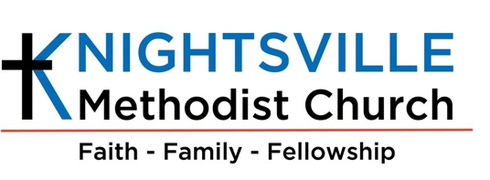

Knightsville Methodist Church
1505 Central Avenue
Summerville, South Carolina 29483
843-875-2117

BACKGROUND CHECK AUTHORIZATION FORM

I authorize Knightsville Methodist Church to conduct a criminal background check.

I certify that I have carefully read and do understand the above statement.

Signature of applicant: ______________________________ Date: _________________

Please print legal name: ___________________________________

SSN: ________________________________

Driver’s License #: _______________________________ State: ___________________

Birthday: _________________

Address: _________________________________________________________________

Former names or other names you have gone by:
_________________________________________________________________________

